**CRM Development Standards**

360 Synergytech declared some standards while creating an automated CRM, which are given as

1. **Clone podio applications**
2. **Map application’s fields**
3. **Update navigation bar URL and podio field’s external ids**
4. **Add tiles in Activity tab**
5. **Import workflows**
6. **Perform testing**

## Clone podio applications:

Go to previous developed CRM, click on an application then click on wrench sign and then select an action i.e. “Clone app”.

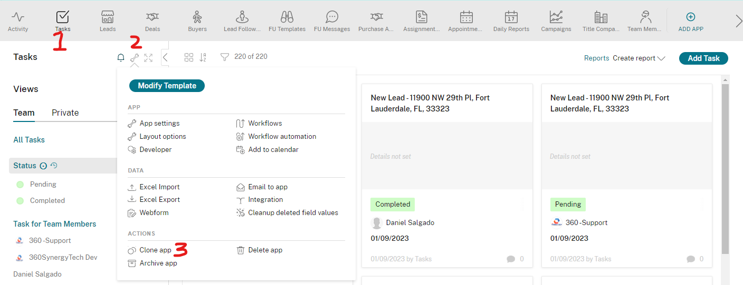

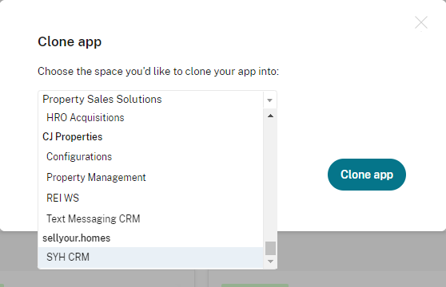Then choose the new workspace from dropdown where you'd like to clone your app.

Moreover, you can also clone the content (items in respective application) of an application if you checked the checkbox under dropdown i.e.

Also clone the contents of the app.

And then click on Clone app button to continue.

**Tip:** Clone FU Templates, FU Messages, Campaigns, Team Member, and Settings applications with content.

After clicking, Podio redirects you to destination workspace (app where you select to clone).

Follow the above cloning instructions for further applications which are given in the following:

* Leads
* Deals
* Buyers
* Lead Follow-ups / Lead Drip Sequence
* FU Templates / Drip Sequence Templates
* FU Messages / Drip Sequence Messages
* Purchase Agreement (Contract App)
* Assignment Contract (Contract App)
* Appointment
* Daily Reports
* Acq Campaign
* Dispo Campaign
* Title Company
* Team Members
* Feeds
* SmrtPhone Tracking Numbers
* Settings

**Note 1:** Lead Follow-ups / Lead Drip Sequence, FU Templates / Drip Sequence Templates, and FU Messages / Drip Sequence Messages are the major application of client follow up.

**Note 2:** Purchase Agreement and Assignment Contract are the major contract / offer application. Mostly, we use the applications for DocuSign integration or sending offer via email to a seller / buyer.

**Note 3:** Configs app is used while updating smrtPhone tracking number. We keep smrtPhone tracking numbers (in JSON format) in config app and then search on the basis of Name field and update Choose smrtPhone tracking Number category field.

**Note 4:** Mostly, we keep configuration key value in Settings app while DocuSign integration with Podio.

## Map application’s fields:

When we clone an application, Podio did not create some calculation fields (in which we get values from referenced application) and also remove references of Relationship fields.

We have to create the missing calculation fields and add references in relationship fields.

## Update navigation bar URL and podio field’s external ids:

When we clone an application, navigation bar calculation fields contain URL of previous application. We have to update the URL in calculation fields (as well as in Back to Top calculation fields).  
Mostly, leads and deals application need these updates.

## Add tiles in Activity tab (Application)

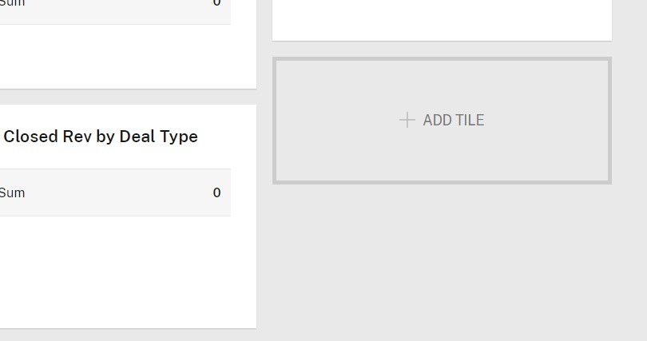“Activity Tab” shows the CRM statistics of quick reports for Client. To add tiles, go to “Activity Tab”, and click on “Add Tile” button.

Then, click on Reports & Charts from left side bar and select the application to base your report on

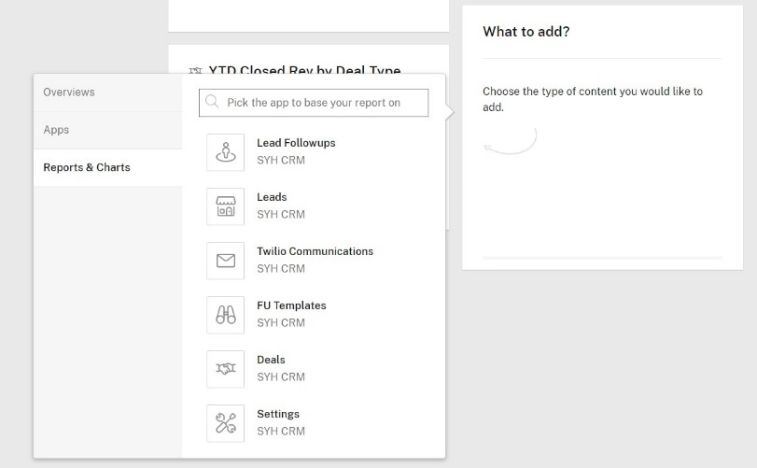

After that, click on “Create a report for this app”

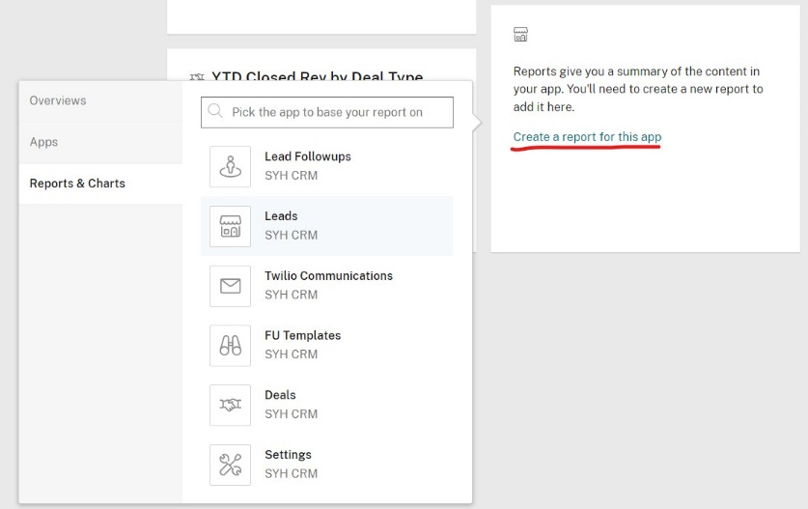

Then, add report data as Count items per None and click Next

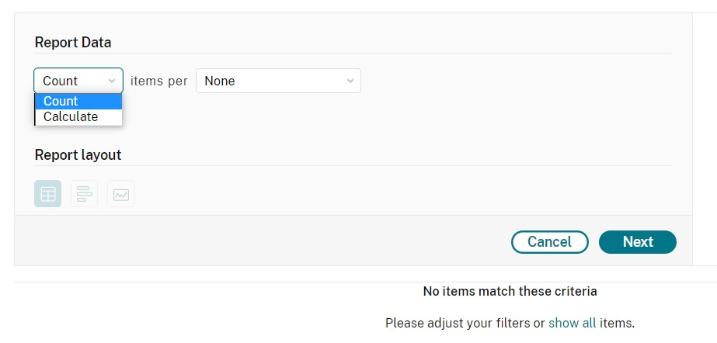

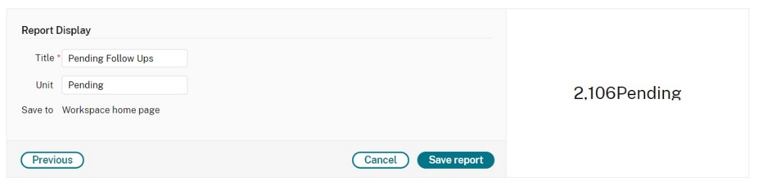After clicking Next, Report Display appears. Give title to your report and set unit name. This is the final step of creating report. Now click on Save report and go to activity tab, you will see the report data into newly generated tile.

## Import Workflows

Import workflows from workflow’s back-up and fix the globiflow token’s (variable’s) error. Make sure reference action is properly referred. Search and Podio View actions are working fine and there is no error in their syntax. If there is an error in Search, Reference, or Podio View action then be aware of For Each loop action (Note: Delete the action and add new For Each loop then you will find the Ref items).

While importing a workflow, be aware, if there is a Trigger another flow action then you have to select the manual flow in dropdown (Make sure manual flow should be created before otherwise you have to create manual flow first then select that manual flow in the dropdown).

Below are some error images that you’ll have to face while importing workflows.

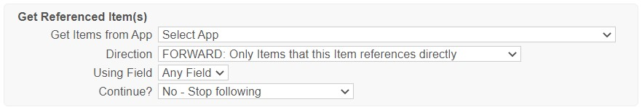





## Testing Workflows

After successfully importing the workflows, perform testing on all the workflows by performing live actions and create scenarios in Podio.